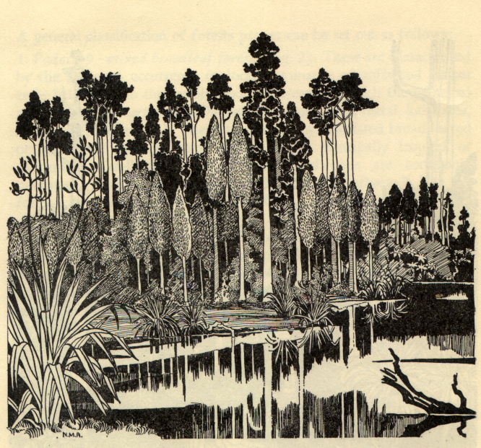

Kahikatea forest, Westland
Nancy Adams

Trans-Tasman Forest History
Conference update, April 2006

The seventh conference of the Australian Forest History Society will be held in Christchurch, New Zealand from 29 January to 2 February 2007 in Christchurch New Zealand. We plan for one session in relation to the eightieth anniversary of the New Zealand Institute of Forestry, while another will look at indigenous people and the forest. Many papers will look beyond New Zealand to Australia and elsewhere, and some papers will look beyond forests to other environmental histories. In addition to two field outings during the conference, we also plan an optional study trip to the West Coast forests from 2 to 4 February.

For further details of the conference (already announced) see the December 2005 newsletter and the AFHS website. Please e-mail all expressions of interest – the sooner the better! - to starmulq@es.co.nz or mail them to Paul Star/Australian Forest History Society, History Dept, University of Otago, PO Box 56, Dunedin, New Zealand.

